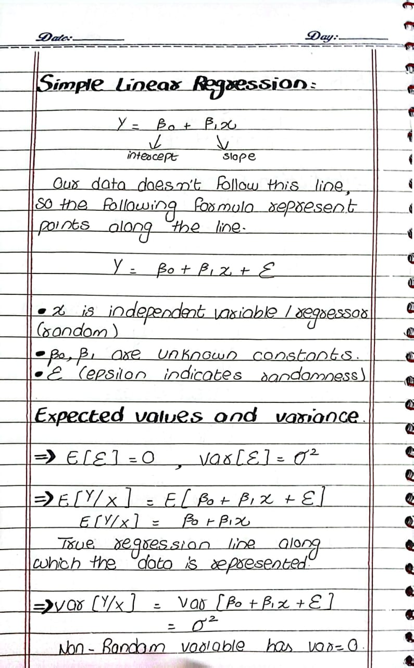
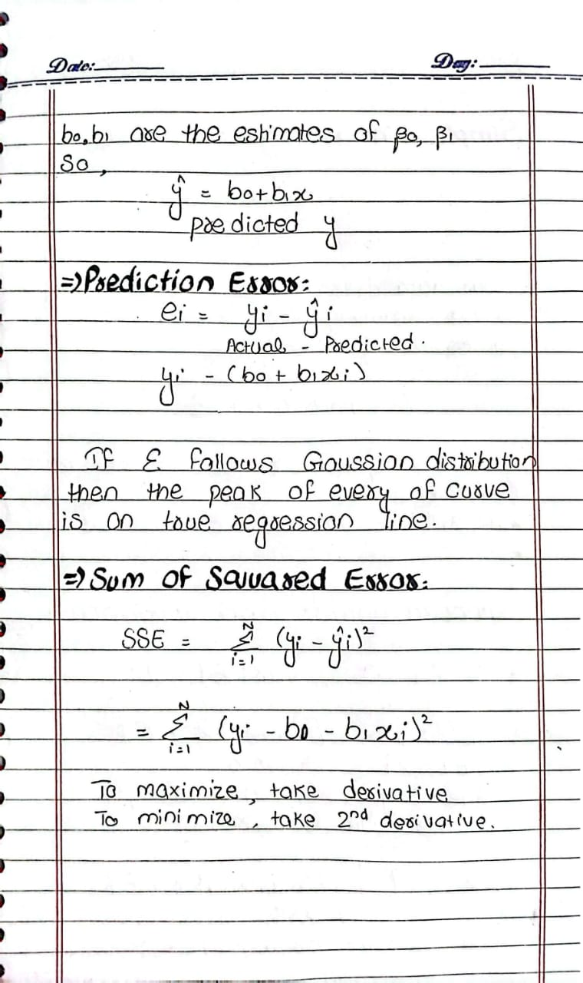
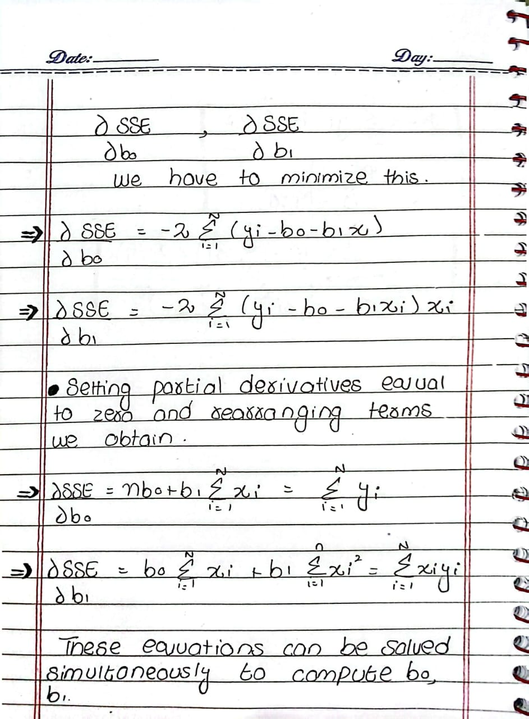
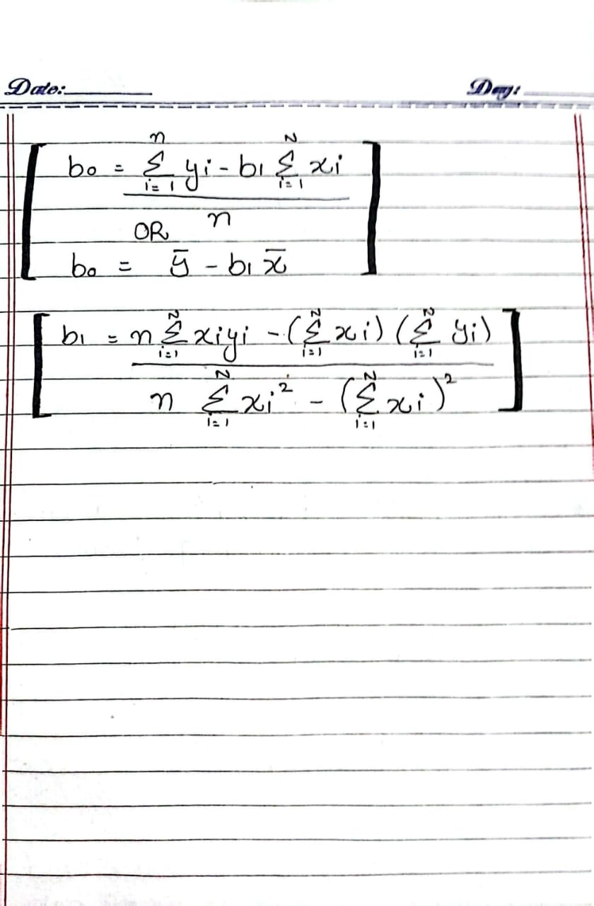

Question: Predicting House Prices using Linear Regression
A real estate company wants to predict house prices based on house size (sq. ft.). The given dataset is:
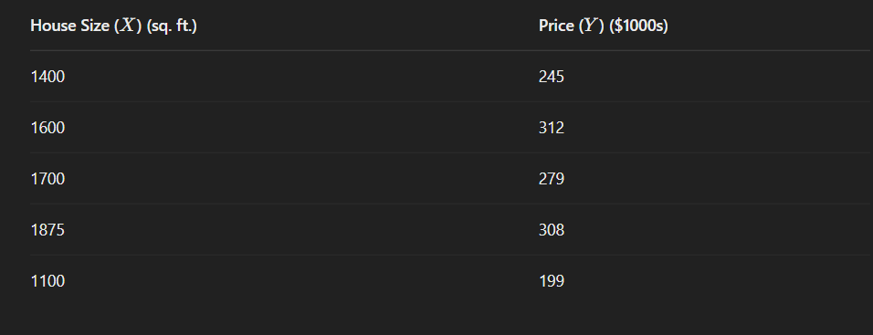
A simple linear regression model is estimated as:
Y^=50+0.12X
- Interpret the coefficients:
  - What does the intercept (50) represent?
  - What does the slope (0.12) represent?
- Make predictions using the given regression equation:
- Calculate the residuals (difference between actual and predicted prices) for each house.
- Analyze the model:
  - If a house's actual price is much higher or lower than the predicted price, what could be the reason?
  - What other factors might improve the accuracy of the model?

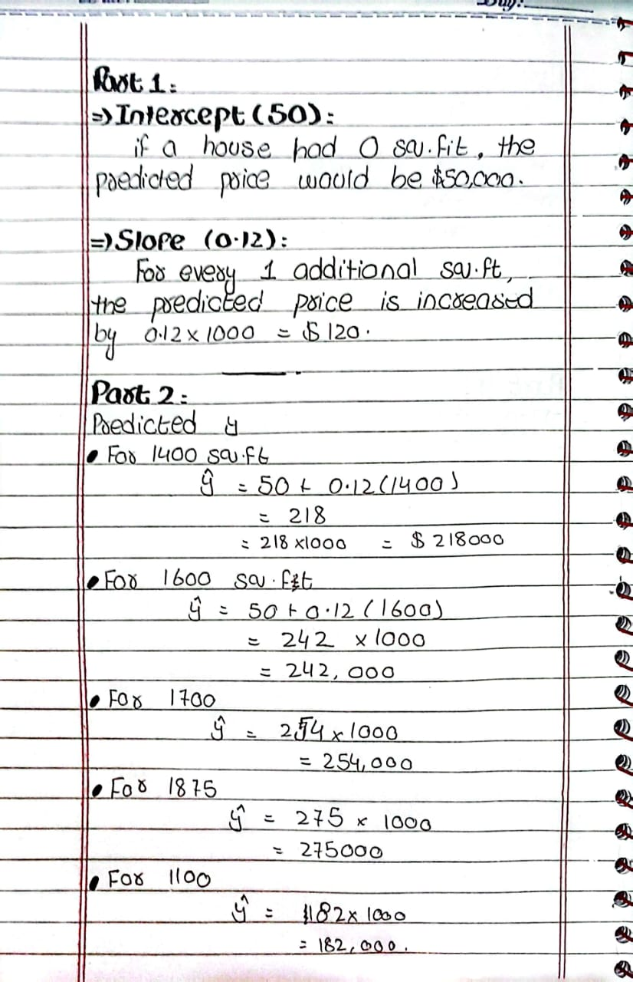
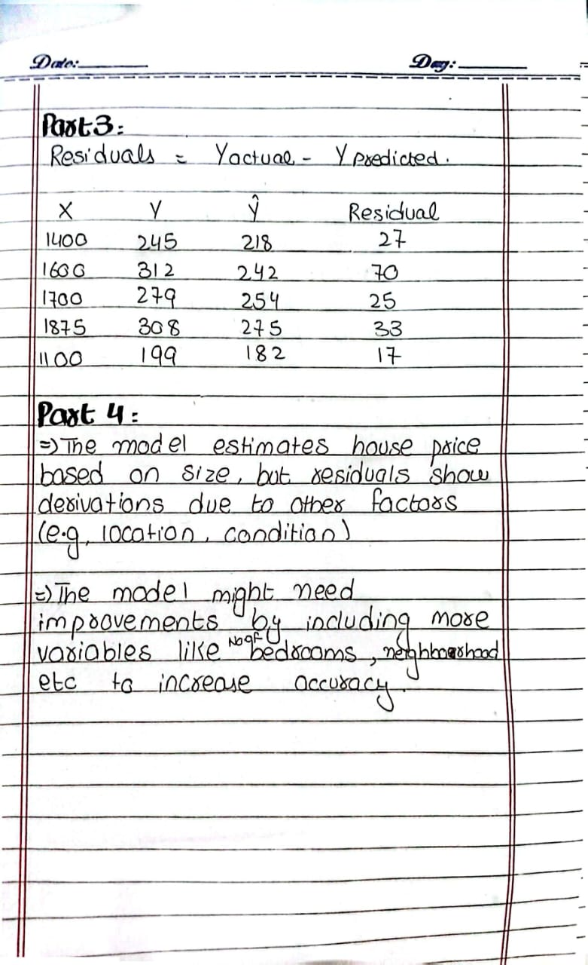

Question 1: A business owner wants to analyze how temperature affects ice cream sales. The following data has been collected:
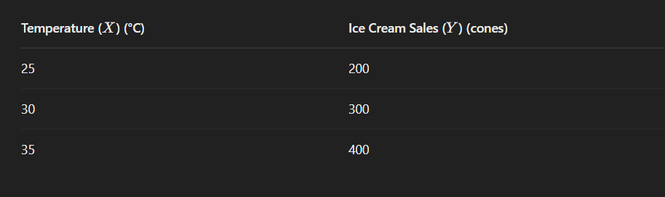
Determine the regression equation ,Predict sales for new temperatures:
- Estimate ice cream sales when the temperature is 28°C. And 40°C.

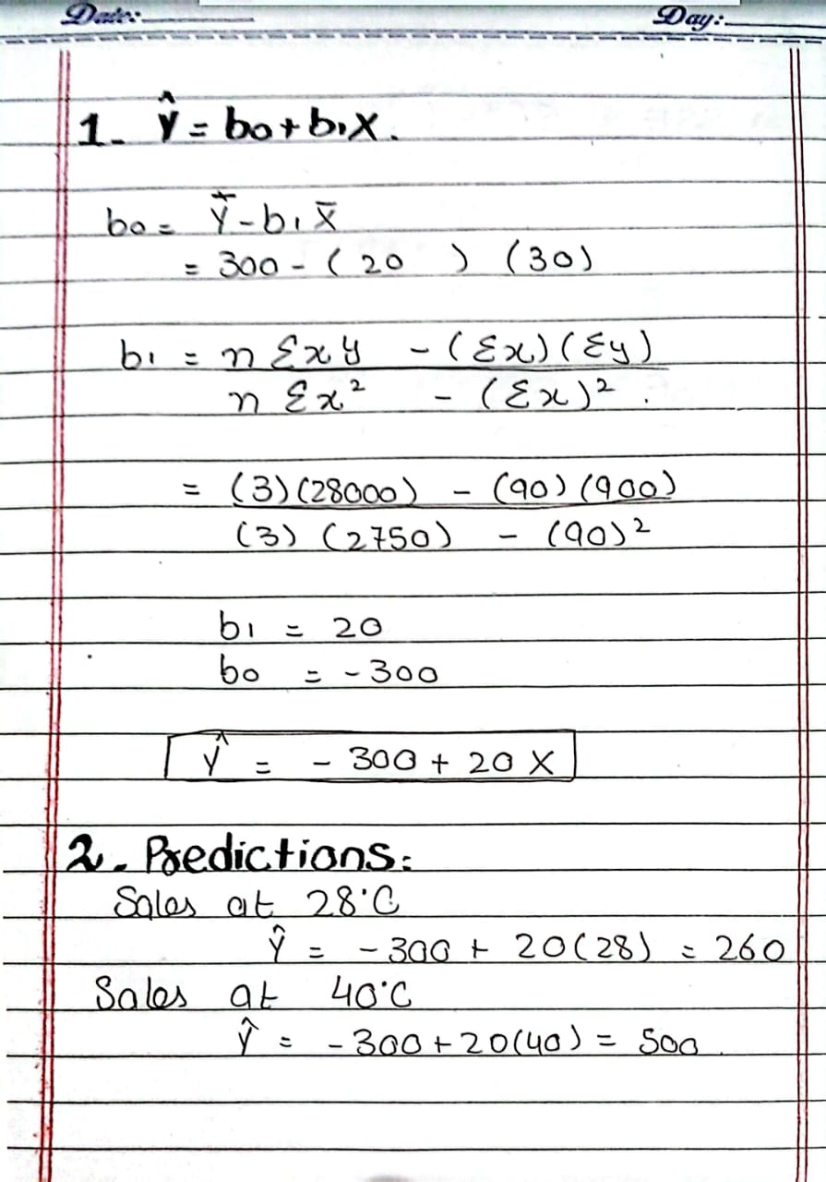

Question 3: Compute SSE (Sum of Squared Errors) and MSE (Mean Squared Error)
Given the actual vs. predicted values:
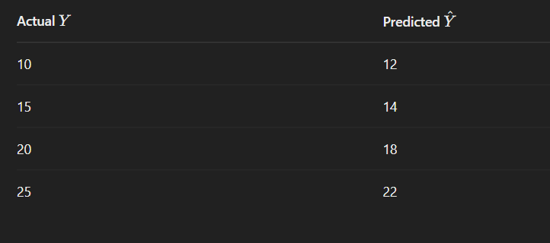
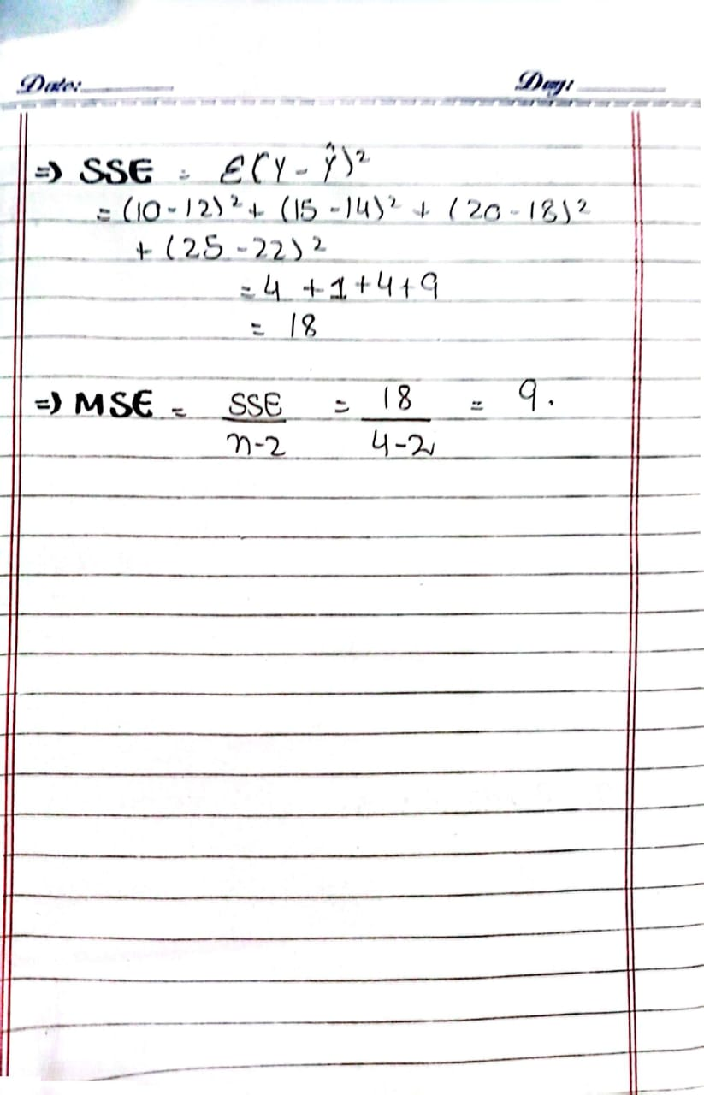

Question:

Temperature (X) | Converted Sugar
1.0 | 8.1
1.1 | 7.8
1.2 | 8.5
1.3 | 9.8
1.4 | 9.5
1.5 | 8.9
1.6 | 8.6
1.7 | 10.2
1.8 | 9.3
1.9 | 9.2
2.0 | 10.5
